Database Tuning
CS5226
Lab 2

A0079953L – LEE ZHONG DE ROLLEI

TABLE OF CONTENT

Question 1: Index-Organized Tables 3
Question 2: Clusters 8

Question 1: Index-Organized Tables
Start up the database with init.ora, and run setup.sql.

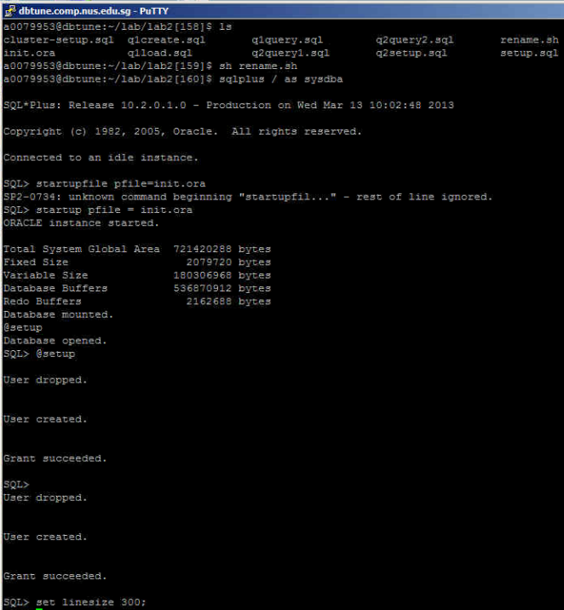

Run q1create.sql to create the table lab2user1.item

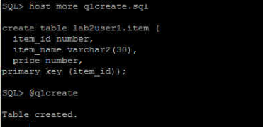

Run q1load.sql to populate the table lab2user1.item.

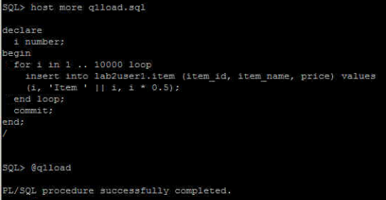
Use the set autotrace command (with the appropriate option) to determine the estimated cost of running the query q1query.sql.

There are several parameters in the autotrace command (as below). However, since we are only interested in the execution cost and not the data nor the statistics, we will use this command “set autotrace traceonly explain” to display the execution plan.

set autotrace off  set autotrace on  set autotrace traceonly  set autotrace on explain  set autotrace on statistics  set autotrace on explain statistics | set autotrace traceonly explain  set autotrace traceonly statistics  set autotrace traceonly explain statistics  set autotrace off explain  set autotrace off statistics  set autotrace off explain statistics

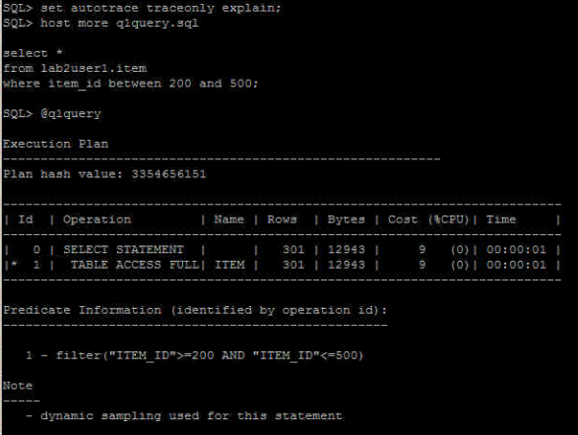
This plan shows the execution of a SELECT statement. The table was accessed using a full table scan. i.e.
- Every row in the table is accessed, and the WHERE clause criteria is evaluated for every row.
- The SELECT statement returns the rows meeting the WHERE clause criteria.

To reduce the running cost, we rebuild the table lab2user1.item as an index-organized table as follows:

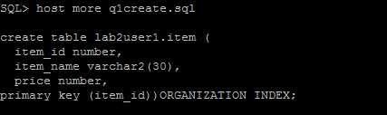

Repeat the steps above to recreate and reload the data and subsequently examine the cost of execution after an organized index is created

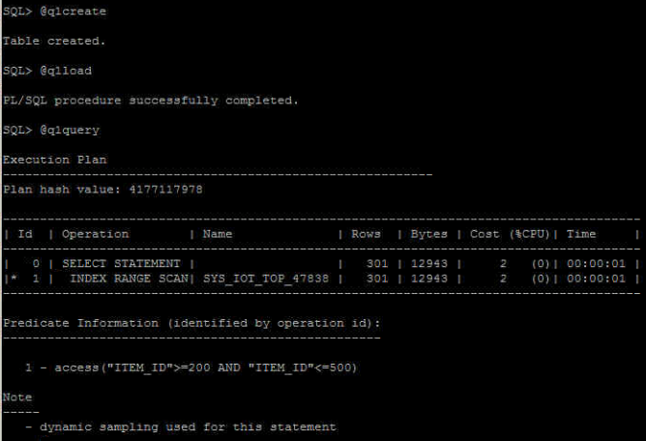

The cost of running q1query.sql has now been reduced. This plan shows execution of a SELECT statement.
- The organized Index (SYS_IOT_TOP_47838) is used in a range scan operation to evaluate the WHERE clause criteria.
- The SELECT statement returns rows satisfying the WHERE clause conditions.

Conclusion

An index-organized table (IOT) stores data in a B-Tree index structure. It also stores all the columns of the row and access the row data via the row’s primary key .This makes scanning of data faster because once a search has located the key value all its corresponding row data will exists in the same location. This avoids the need to perform a look up in the table hence making the scanning more efficient. Also, there is no need to store duplicate key in the index and table (since both are in the same segment), hence this will help to save storage space.

IOT are useful when related pieces of data must be stored together or data must be physically stored in a specific order. i.e. if the query pattern is such that all column data must always be returned together or if the query pattern is such that the data must always be sorted in specific order. Tables that are queried by the key, not updated frequently and can fit well into a block are also good candidates for IOT

Question 2: Clusters

Run q2setup.sql.

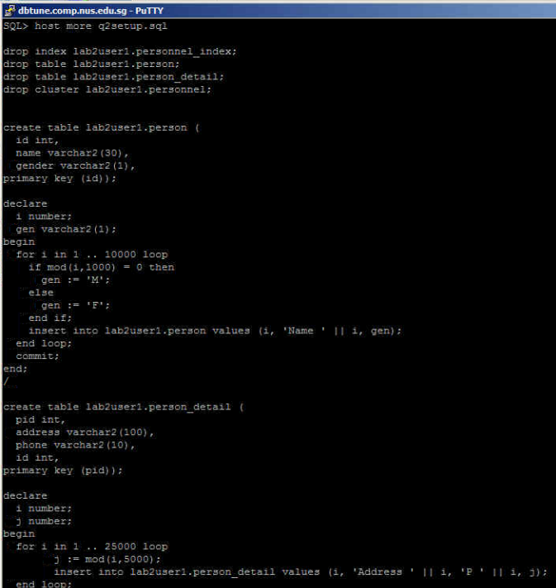
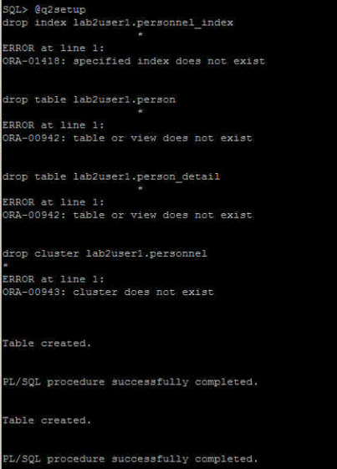
Determine the estimated cost of running the query q2query1.sql.
Determine the estimated cost of running the query q2query2.sql.
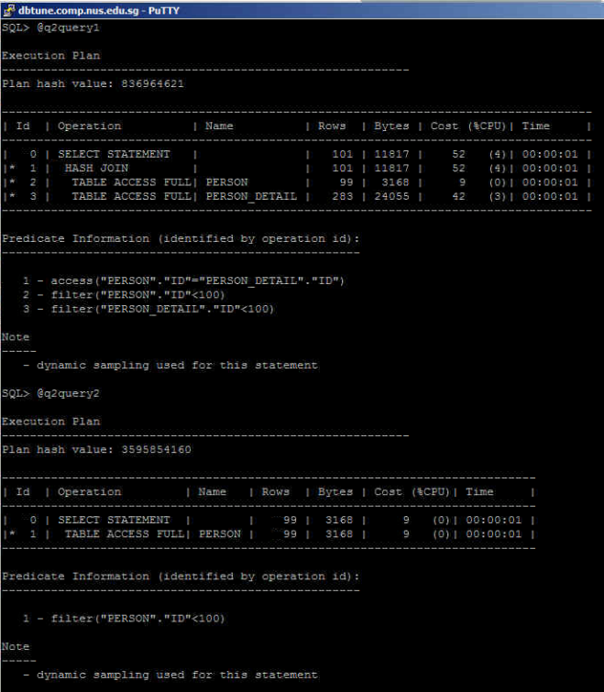
Modify cluster-setup.sql to create a cluster and a cluster index for the two tables referenced in q2query1.sql using the cluster name ’lab2user1.personnel’.

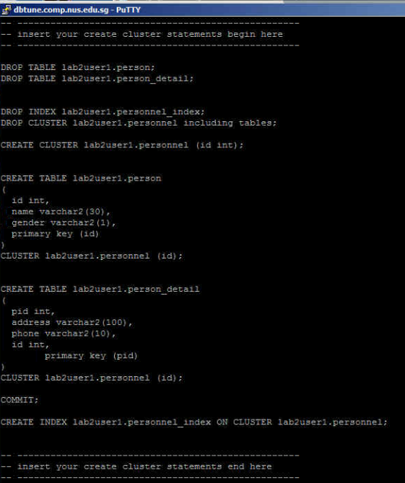
Execute modified cluster-setup.sql

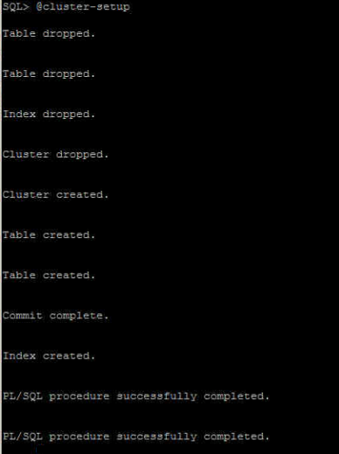

Rerun query 1 and 2 after the creation of cluster and add tables to the cluster created. The cost of the2 queries have then been reduced

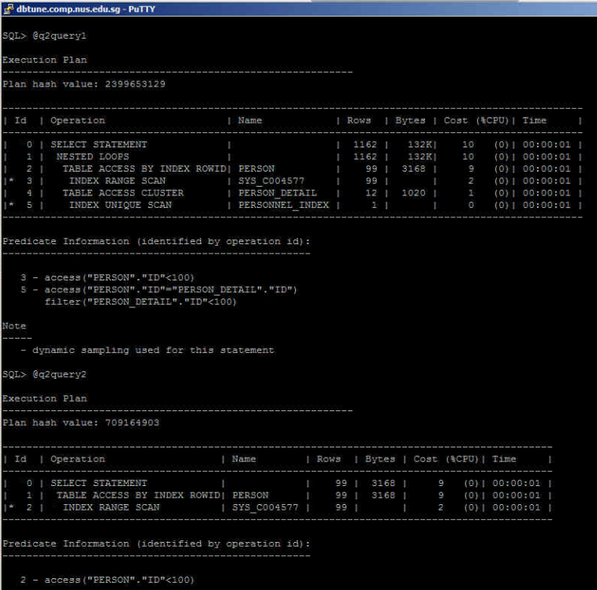
Conclusion

A table cluster is a group of tables that share common columns and store related data in the same blocks. When tables are clustered, a single data block can contain rows from multiple tables. In the example above, both tables person and person_detail are created in the same cluster “lab2user1.personnel”, therefore each oracle block will be able to store data from these 2 tables rather than from a single table.

The cluster key is the column or columns that the clustered tables have in common. For example, person and person_dtail shared the same id column. The cluster key has to be specified when creating the table cluster and when adding new table to the cluster

The cluster key value is the value of the cluster key columns for a particular set of rows. All data that contains the same cluster key value, such as id=20, is physically stored together. Each cluster key value is stored only once in the cluster and the cluster index, no matter how many rows of different tables contain the value.

We can consider clustering tables when they are primarily queried (but not modified) and records from the tables are frequently queried together or joined. Because table clusters store related rows of different tables in the same data blocks, properly used table clusters offer the following benefits over nonclustered tables:

- Disk I/O is reduced for joins of clustered tables.
- Access time improves for joins of clustered tables.
- Less storage is required to store related table and index data because the cluster key value is not stored repeatedly for each row.

Typically, clustering tables is not appropriate in the following situations:

- The tables are frequently updated.
- The tables frequently require a full table scan.
- The tables require truncating.

